

Assessment Cover Page
Sumi Heo

2026324
Assessment Title
CA1 -Machine Learning
Lecturer/Supervisor
Dr. Muhammad Iqbal
Assessment Due Date
15/11/2026
Date of Submission
15/11/2026

Use of AI Tools
I acknowledge the use of Gemini for the purpose of getting additional idea for my project.
Declaration
By submitting this assessment, I confirm that I have read the CCT policy on academic misconduct and understand the implications of submitting work that is not my own or does not appropriately reference material taken from a third party or other source.
I declare it to be my own work and that all material from third parties has been appropriately referenced.
I further confirm that this work has not previously been submitted for assessment by myself or someone else in CCT College Dublin or any other higher education institution.
Contents
1. Introduction 4
2. Dataset Description 4
3. Data cleaning & Preprocessinig
. Visualization 13
4. SVC 16
5-1. SVC 17
5-1. SVC after scaling 18
5-1. Hyperparameter 18
5-1. Cross Validation 18
5. Random Forest
5-1. RandomForest 17
5-1. Hyperparameter 18
5-1. Cross Validation 18
6. Compare algorithms
6-1. Before SMOTE 19
6-1. After SMOTE 22
7. Appendix 25
8. References 28

Introduction
Diabetes is a disease affecting millions of people worldwide. According to the WHO, 830 million adults had diabetes in 2022. This is a 7 percent increase from 1990 and amounts to about 14 percent in 2022. It is also associated with serious complications such as heart attack, stroke, and kidney failure. Therefore, it is important not only to detect and manage diabetes early through patients' health-related information but also to prevent it. This assignment aims to analyze a diabetes dataset and build a binary classification model to predict whether an individual person has diabetes or not. The results were predicted based on the target variable, 'Outcome,' and the performance was evaluated by comparing two machine learning algorithms: Support Vector Classifier (SVC) and Random Forest. Additionally, I apply GridSearchCV to evaluate whether it can improve model performance by finding optimal parameters.

Questions
- Which column is the most related to the target variable? Glucose
- Is it necessary to do dimensionality reduction? NO
- What method should be used for encoding? Manually mapping
- Can the imbalance in target variable impact to the result? Yes
- How can I make the performance better? By using standard scaler
I will explain everything below.

Dataset Description
The dataset which is from Tuhin, Izaz Ahmmed ; SIAM, A K M FAZLUL KOBIR; Haque, Md Afzalul (2025) was read named ‘df’ by DataFrame. Through the df.shape function, it was checked that the dataset consists of 20,000 rows and 15 columns. Using df.info(), it is revealed 8 numerical variables - ‘Age’, ‘Glucose’, ‘Blood Pressure’, ‘Skin Thickness’, ‘Insulin’, ‘BMI’, ‘Cholesterol’, ‘Diabetes Pedigree Function’ and 7 categorical variables - ‘Gender’, ‘Physical Activity’, ‘Smoking Status’, ‘Alcohol Intake’, ‘Family History’, ‘Hypertension’ and ‘Outcome’. I can indicate each column’s descriptive statistics by function df.descirbe(). For example, numerical variable ‘Glucose’ has 119.6 mean, 120 median, and 29.6 standard deviation, showing a almost symmetric distribution. Also, for the main column ‘Outcome’ shows that there ae 20,000 total values consisting of 16,726 ‘Diabetic’ class and 3,274 ‘Non-diabetic’ class. Checking with df.isnull().sum() code revealed 9,925 missing values in the ‘Alcohol Intake’ column. 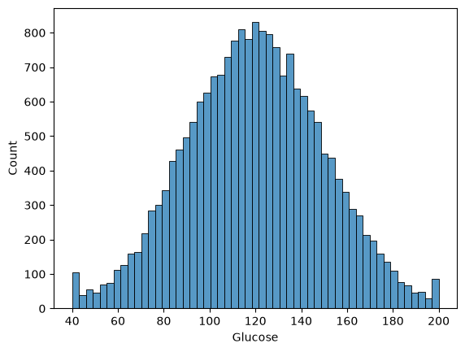

Data cleaning& Preprocessing
As it is referred, the 9,925 missing values were in ‘Alcohol Intake’. It occurred because Python automatically recognized the string value ‘None’ as nan. To resolve this, it is replaced with the original string value ‘None’ using the fillna() function. After that, there is no more missing values across all columns. After cleaning all dataset without missing values, all values required to be changed as numerical values to be used for machine learning. But what method should be used for encoding? In this project, three encoding methods were evaluated. First, it was Ordinal Encoding for Independent variable and Label Encoding for Target Variable. This approach considers the order between values. However, if I choose this method, nominal variables like ‘Gender’ could cause the computer to learn incorrect order relationships. So, I did not choose this one. Second way is one-hot-encoding. This method was not picked as well because of excessive expansion of feature dimensions. For the last, a custom mapping strategy was chosen. The most important column ‘Outcome’ has been mapped by 1 for Diabetic and 0 for Non-diabetic.
Feature | Mapping values
Physical Activity | Low = 0, Moderate = 1, High = 2
Smoking Status | Never = 0, Former = 1, Current = 2
Alcohol Intake | None = 0, Occasional = 1, Regular = 2
Gender | Male = 0, Female = 1
Family History | No = 0, Yes = 1
Hypertension | No = 0, Yes = 1
Outcome (target) | Non-diabetic = 0, Diabetic = 1

Visualization
Countplot shows a class imbalance in the target variable ‘Outcome’, which Non-diabetic(0) is much lesser than Diabetic(1). Can this imbalance influence the result? The answer could be yes. So, I used Recall and F1-score as the primary metric in this project. And I questioned by myself that ‘Which variable is the most associated with the target feature?’ The answer can be found from the pairplot which is ‘Glucose’. Looking at the relationship between glucose and outcome in the graph, higher glucose levels result in a 1 (diabetic) outcome. This was also confirmed using a bar plot and a scatterplot. Non-diabetic value shows a median about 80 in a boxplot but diabetic class is around 130 with outliers reaching up to 200, while other columns show little correlation with ‘Outcome’ in boxplots.
Another question arose. Do I have to do dimensionality reduction in this dataset? This is a process to solve the curse of dimensionality issue that occurs as the number of columns increases. I could check it through a heatmap. Since the diagonal is a comparison with oneself, it must show a distinct color. However, for example, although the colors of glucose and outcome, or BMI and outcome, are darker than other categories, they mostly show values close to zero. It suggests that the influence among the columns is low. In other words, as an answer to the question, dimensionality reduction is not necessary. This means that a computer can analyze about 15 columns without any problem in a python environment.
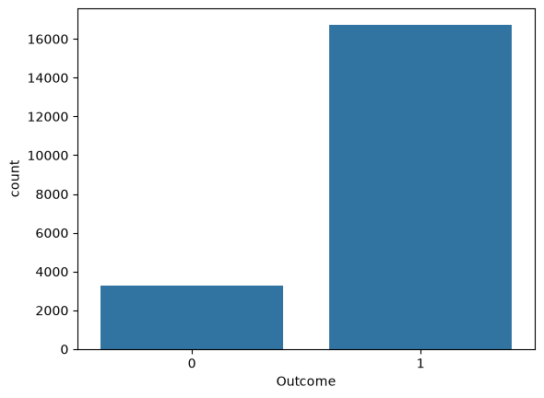
Figure 1
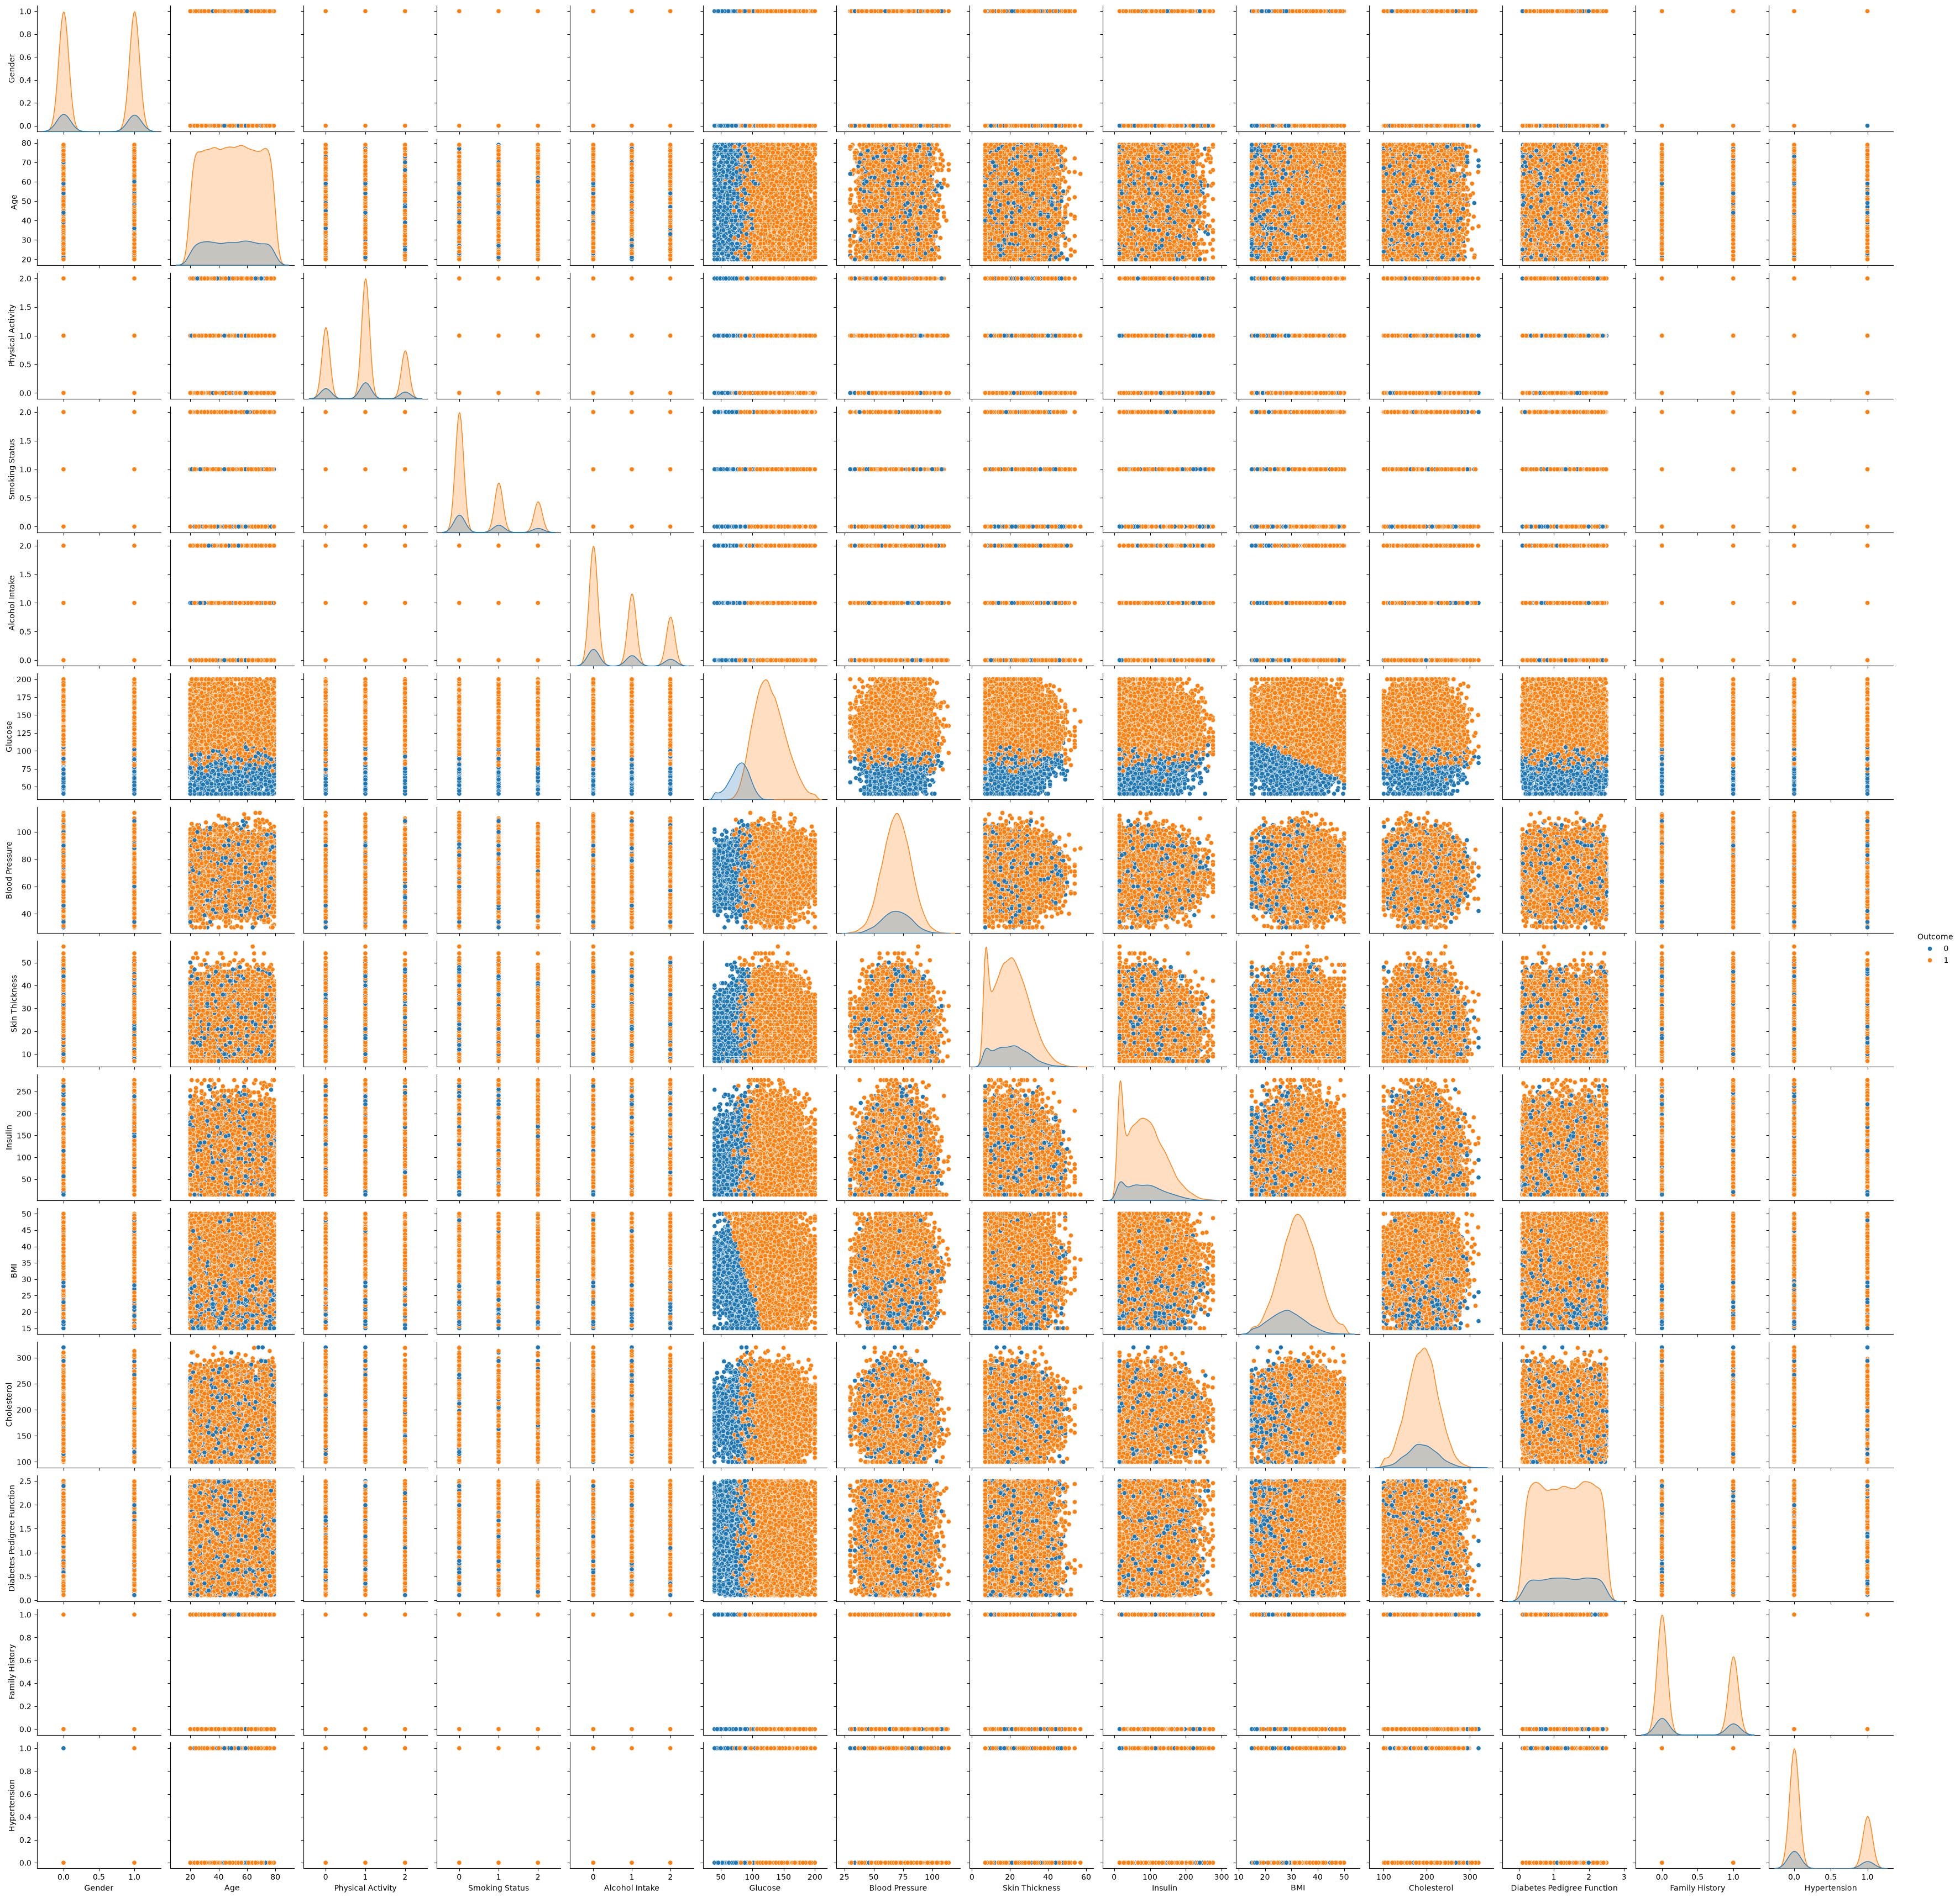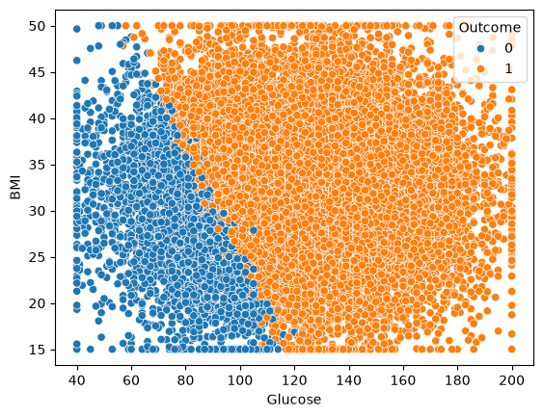
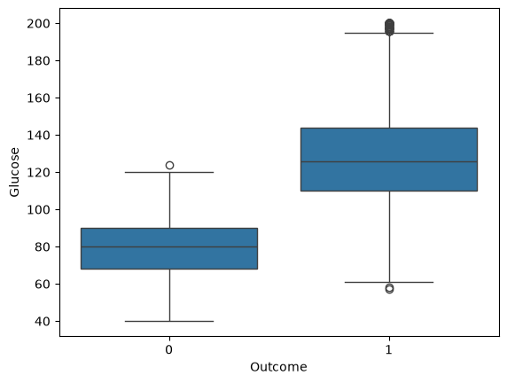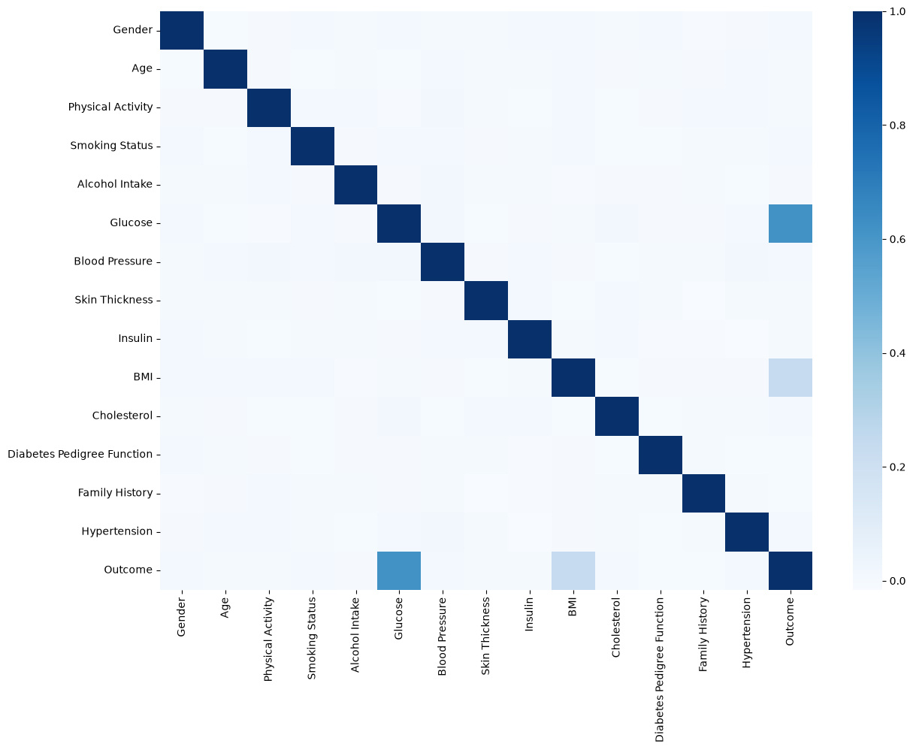

SVC
First, I chose Support Vector Cognition (SVC) algorithm. SVC is a supervised classification algorithm. This Dataset is divided into binary classes Diabetic and Non-diabetic. What it was explained in the lecture is that SVC defines a decision boundary along with a maximal margin that separates almost all the points into two classes. And SVC is coming up with an optimal hyperplane which will classify the different classes and provide strong regularization against overfitting. Also, this dataset is non-linear relationship which involves multiple conditions. Its output does not increase proportionally with increase in input value like linear relationship. SVC helps to manage non-linear relationships well.

SVC
To use SVC, import SVC, train_test_split and metrics for performance evaluation such as recall, f1-score from sklearn. In this project, I used various train-test split ratios like 25%, 20%, 15%, 5% with random_state=42 to keep the result consistent. I split the feature matrix X including all columns except Outcome and y for a target variable Outcome. Using a 25% test split, It was set 15,000 values as train data, and 5,000 for test data. I used set_config code because an error about ‘cp949’ kept occurring because the file was not able to be read as text. For evaluating the SVC model, I compared confusion matrix and classification_report metrics. In the confusion it was occupied by 731 true negatives (correctly predicted Non-diabetic) and 4,110 true positives (correctly predicted Diabetic), while 106 false negatives(Predicted as Non-diabetic but it was diabetic) and 53 false positives(predicted as Diabetic but it was Non-diabetic). By classification report, Non-diabetic classes achieved a recall and f1-score of 87% and 90% and Diabetic classes were 99% and 98%. The model accuracy was 97% which implies high-performance model. Varying the test split ratios showed consistent performance through 20%, 15% as well. But at 5%, the performance slightly dropped. I compared all the confusion matrixes and performance results below.
SVC  Before Scaling | Test size  25% | 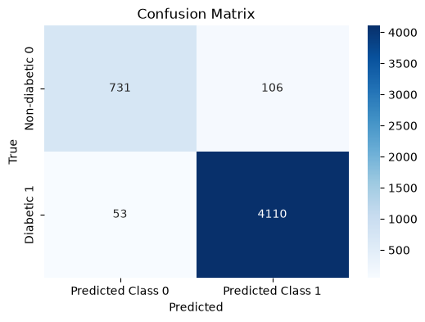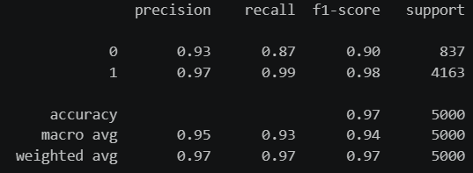
SVC  Before Scaling | Test size  20% | 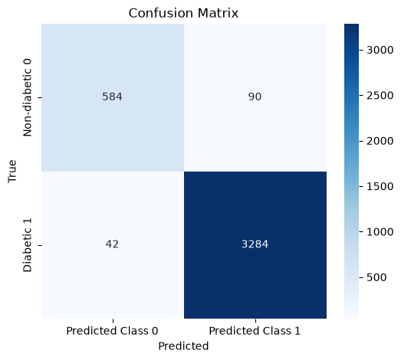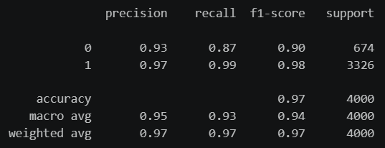
SVC  Before Scaling | Test size  15% | 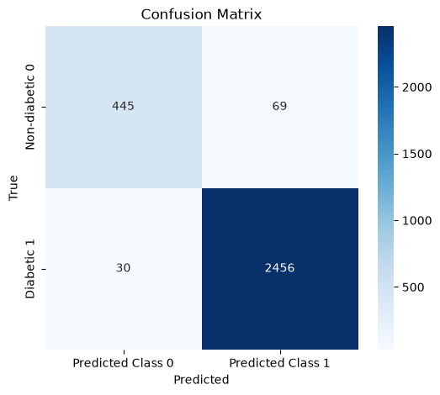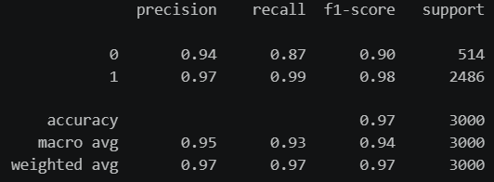
SVC  Before Scaling | Test size 5% | 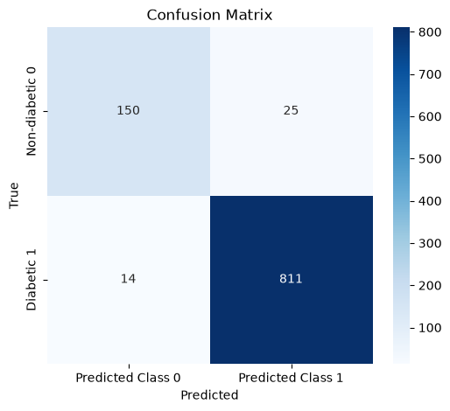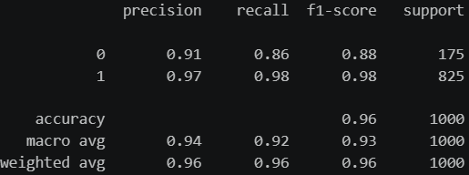

SVC after scaling
Now I have another question. ‘How can I make it perform better?’ So I applied Standard scaling. I chose it SVC is sensitive to differences in feature scales. Standardisation transforms the features to have a mean of approximately zero and a standard deviation of one, helping prevent variables with larger numerical ranges from dominating the model. After applying fit_transform on the training set and just transform on the test set, it resulted in slightly improved outcomes. Especially, the 20% test size showed a bit better performance than the others in f1-score of 1(Diabetic). The thing is that if Train accuracy is high and the test accuracy is low, it can cause over or underfitting but in this case, both are high and similar. It indicates that generalization was good. Also, I summarized the comparison below.

SVC  After Scaling | Test size  25% | 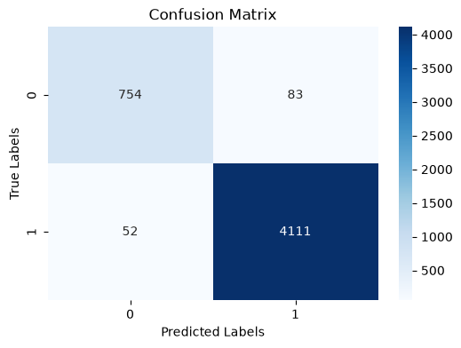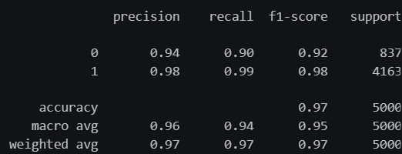
SVC  After Scaling | Test size  20% | 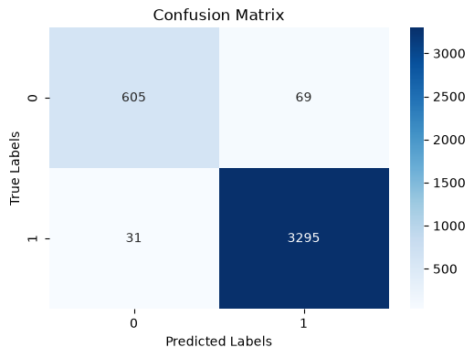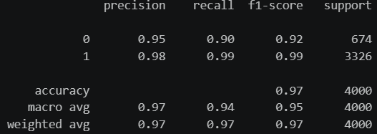
SVC  After Scaling | Test size  15% | 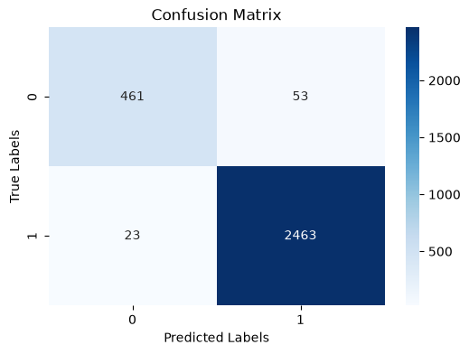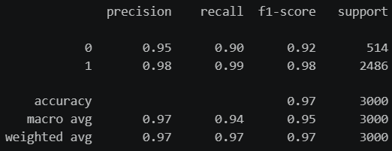
SVC  After Scaling | Test size 5% | 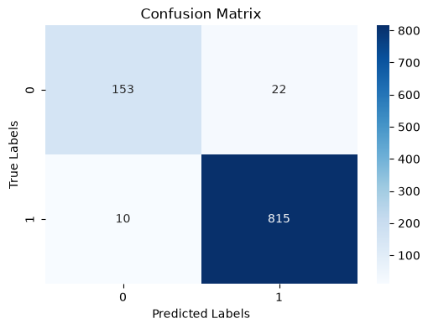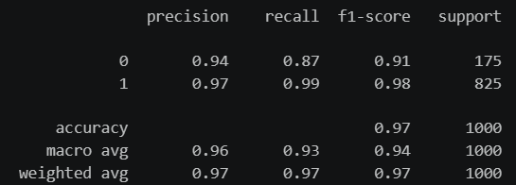

Hyperparameter
I tried to find the optimal hyperparameter to prevent overfitting and maximize the general performance. When I checked the optimal parameter using GridSearchCV, the results were same across all the test sizes. I chose 3-fold cross validation. It was SVC(C=100, gamma=0.001). Comparing this optimized model against the scaled 20% test size, the Non-diabetic recall improved by 0.01 but the Diabetic F1-score decreased by 0.01 after GridSearchCV. The overall accuracy was same. Therefore, it can be interpreted that there is little difference. The table shows the result after applying optimal hyperparameter.
SVC  Hyperparameter | Test size  25% | 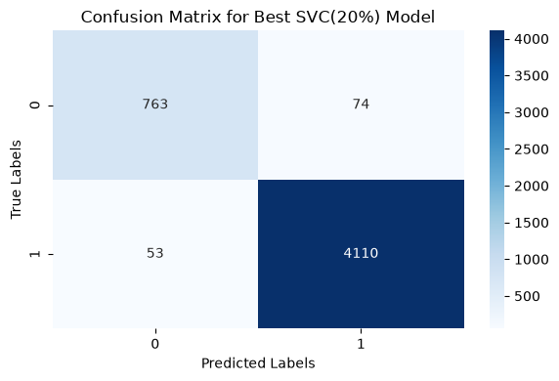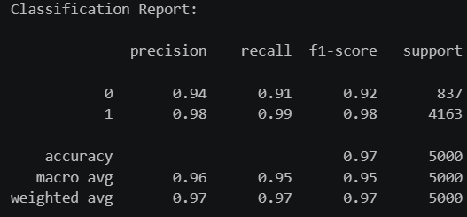
SVC  Hyperparameter | Test size  20% | 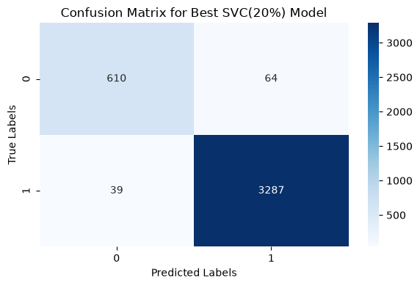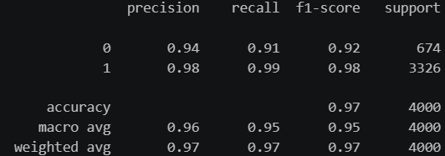
SVC  Hyperparameter | Test size  15% | 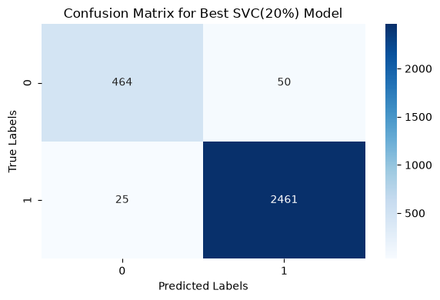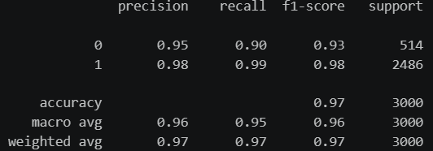
SVC  Hyperparameter | Test size 5% | 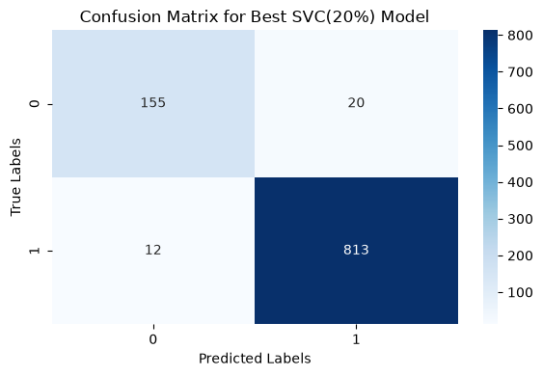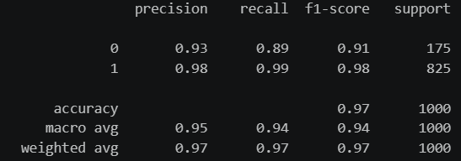

Cross Validation
To improve model evaluation, a 10-fold cross-validation was used on the entire dataset. This method divides the data into 10 groups and then selects one test group from each fold alternately for training and testing and compares performance by averaging the overall accuracy. As a result, it showed a very low standard deviation of about 0.003 and a high mean of 97.3%. This suggests that the SVC model is stable and performs well.
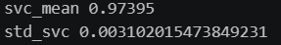

Random Forest
Second, I picked Random Forest algorithm. It creates decision trees and selects the best option by means from each tree that it predicted. I tried decision tree before, but I realized that random forest would perform better with non-linear relationship dataset. And it can be prevented from overfitting. Also, it is used both for classification and regression, so it predicts well with the dataset containing a mix of numerical and categorical variables.

Random Forest
Same as SVC, I imported RandomForestClassifier from sklearn. I used 25%, 20%, 15%, 5% ratios as well with class_weight=’balanced’ to solve the imbalance from values of Outcome. Gini was added to find the optimal split when splitting data, and max_depth is used for regularization to prevent the model from becoming too complex. Looking over the first 20 predictions by function head(20), I can see that the 5th, 11th, 18th predictions were false which means incorrect. The confusion matrix showed it was occupied by 795 true and 3787 true positives, while 31 false negatives and 387 false positives. The Non-diabetic’s recall and f1-score are 96%,79% and Diabetic’s recall and f1-score are 91%,95%. The accuracy is 92%, which is lower than SVC. But comparing with different ratios, the 20% of split test size performs the best with 93% of accuracy and 97% of recall, 82% of f1-score of Non-diabetic, 92% of recall, 96% of f1-score of Diabetic values. When I compared with scaled results, I realized it is same as the result before scaling. So, I only left the result of 25% test size scaled one. I attached the scaled result separately.
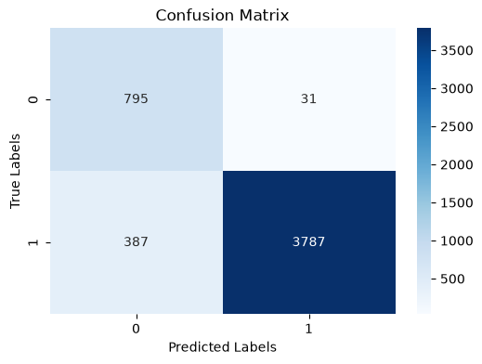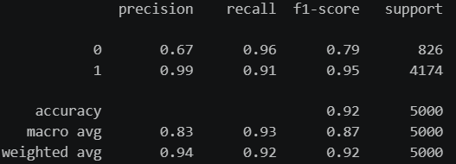

RF  Before Scaling | Test size  25% | 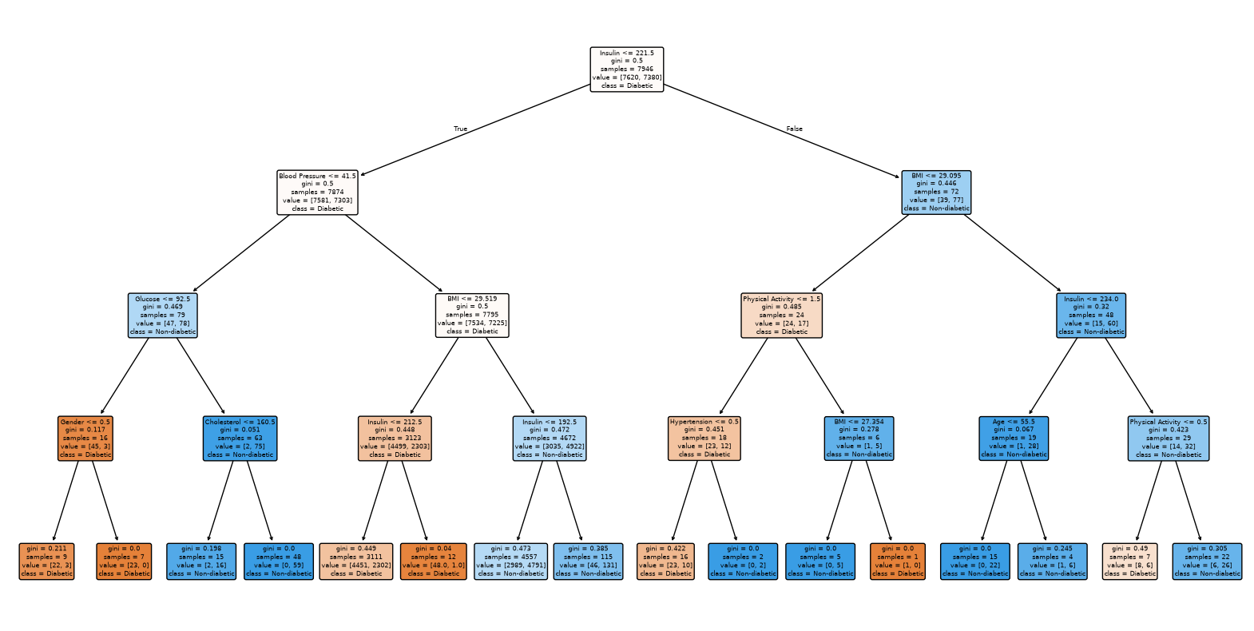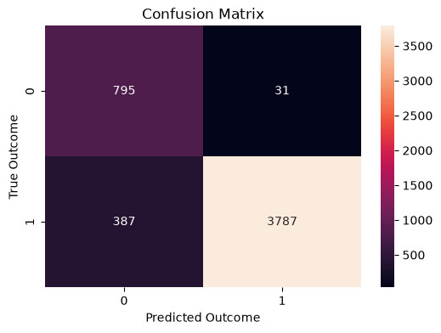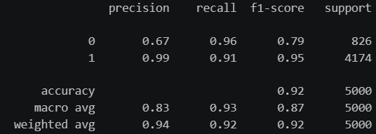
RF  Before Scaling | Test size  20% | 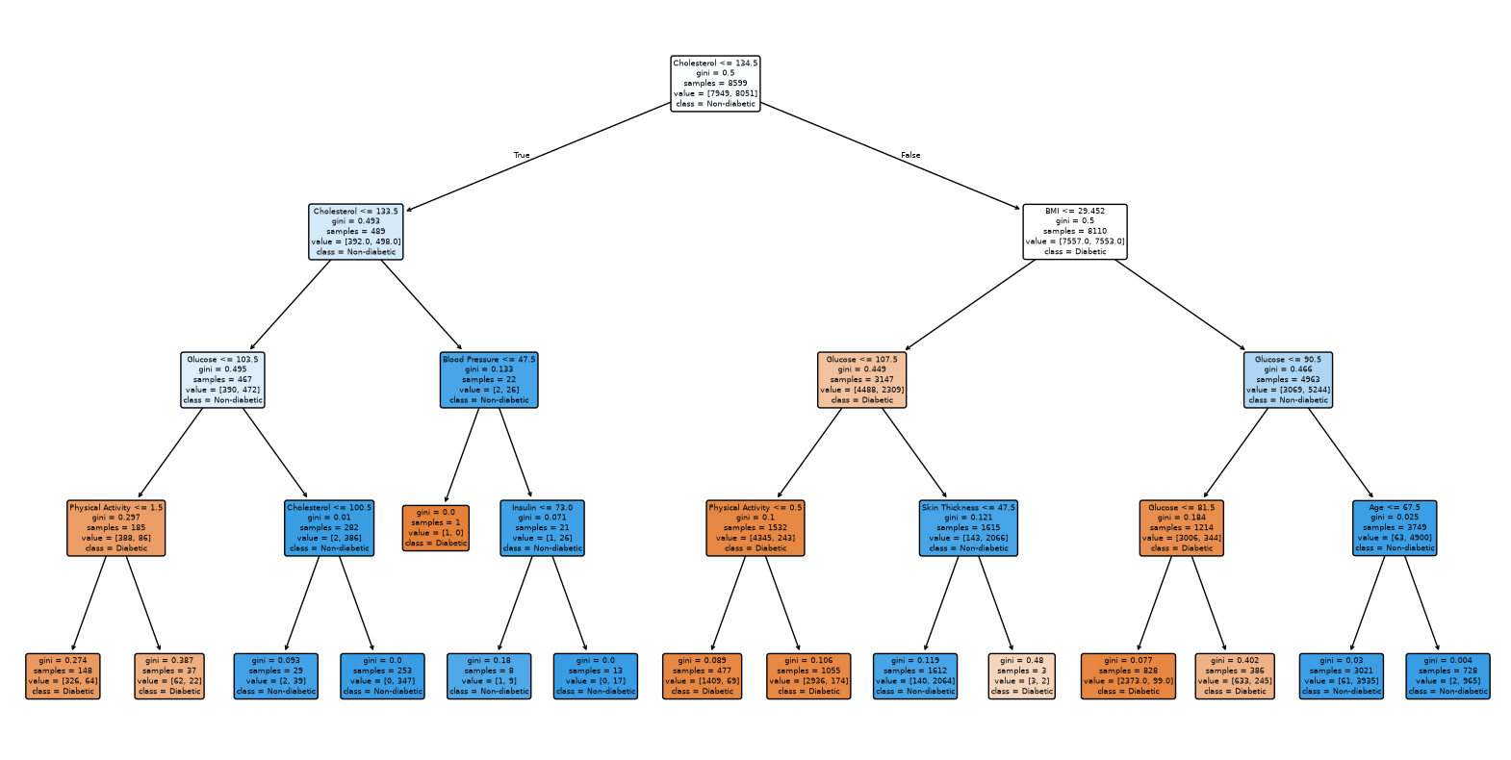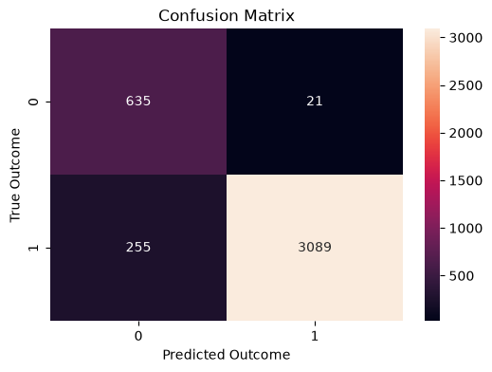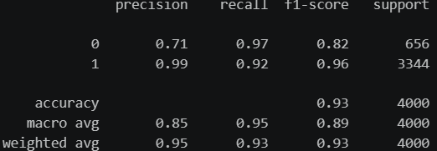
RF  Before Scaling | Test size  15% | 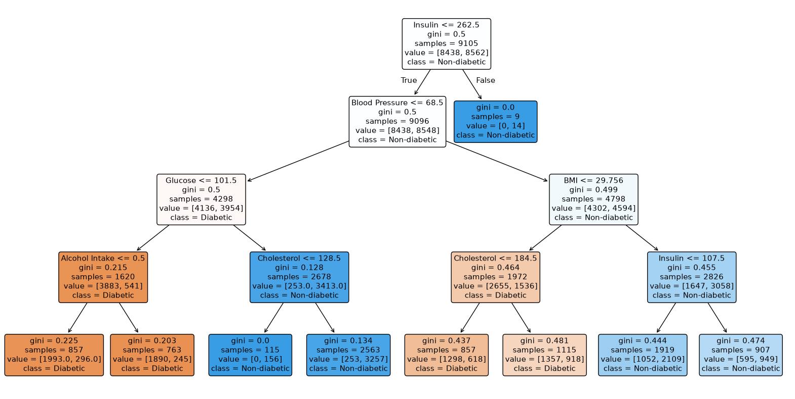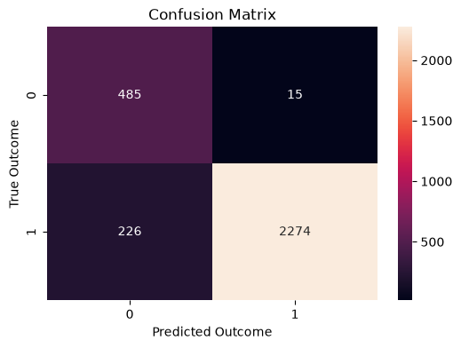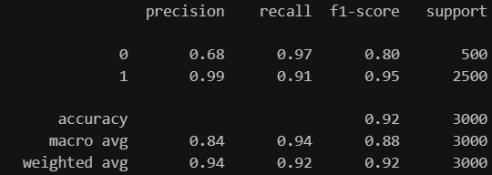
RF  Before Scaling | Test size 5% | 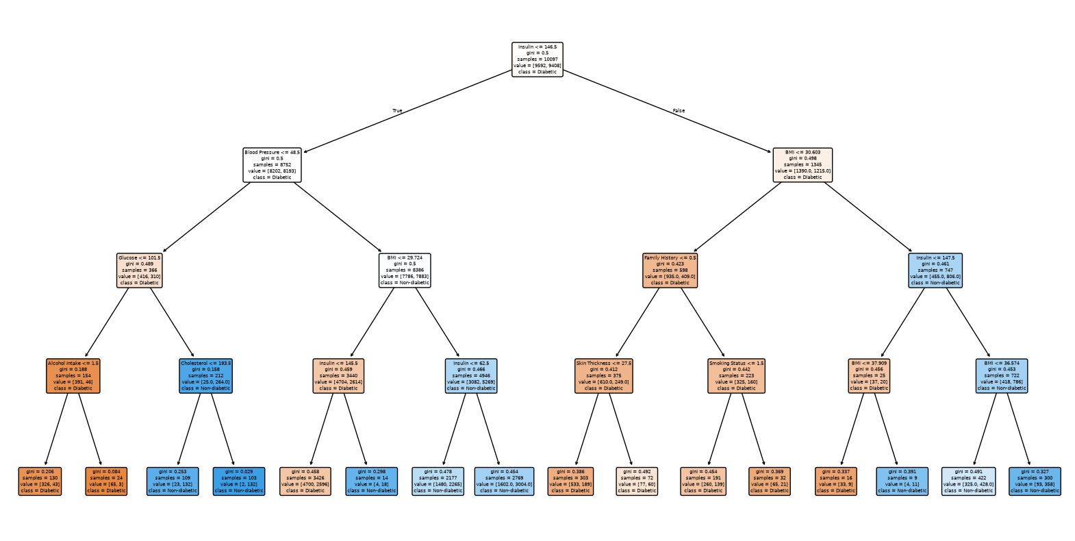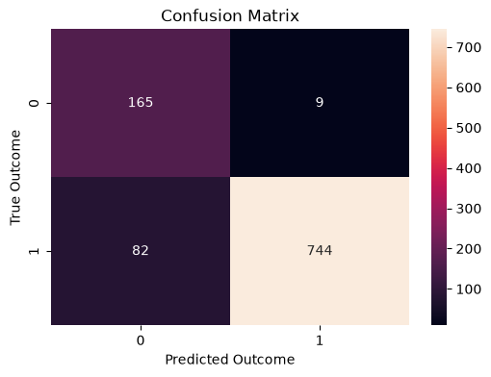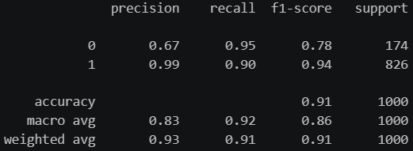

Hyperparameter
First, max_depth was set to 3, 5, and 7 to limit the maximum depth that can extend from the root. If it is too large, it can cause overfitting and if it is too small, it can cause underfitting. I also set the number of trees to be generated using n_estimators, and the number of features to consider as max_features = 5,10, with a maximum of 14. Since the dataset has a total of 14 features excluding the target variable, 14 was set as the maximum. Finally, I set the min_samples_leaf to 1, 2, or 4 to determine when to stop pruning. Increasing this value can help reduce model complexity and limit overfitting.
The results became more reliable through hyperparameter tuning. It was confirmed that for a 25% test size, the optimal parameters 'max_depth': 7, 'max_features': 10, 'min_samples_leaf': 1, 'n_estimators': 100. At the test size 25%, it performed the best with accuracy at 98%. Recall and f1-score are 92% and 93% when non-diabetic, and recall and f1-score are 99% and 99% when it is diabetic. It shows a clear improvement.
RF  Hyperparameter | Test size  25% | 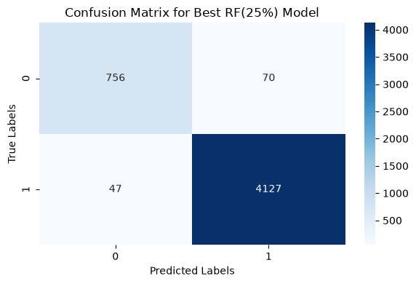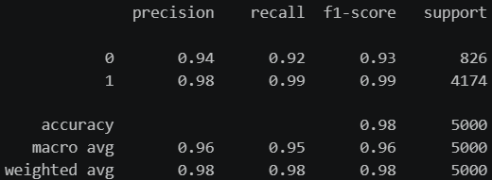
RF  Hyperparameter | Test size  25% | Best Parameters : { 'max_depth': 7, 'max_features': 10, 'min_samples_leaf': 1, 'n_estimators': 100}  Best Estimator : RandomFroestClassifier(max_depth=7, max_features=10)
RF  Hyperparameter | Test size  20% | 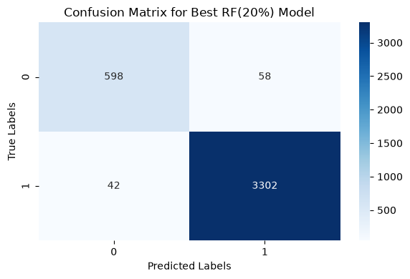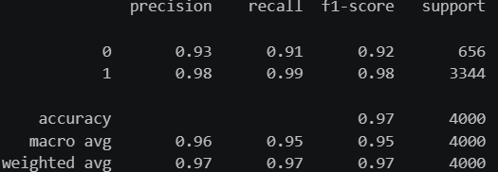
RF  Hyperparameter | Test size  20% | Best Parameters : {‘max_depth': 5, 'max_features': 14, 'min_samples_leaf': 4, 'n_estimators': 100}  Best Estimator : RandomFroestClassifier(max_depth=5, max_features=14, min_samples_leaf=4)
RF  Hyperparameter | Test size  15% | 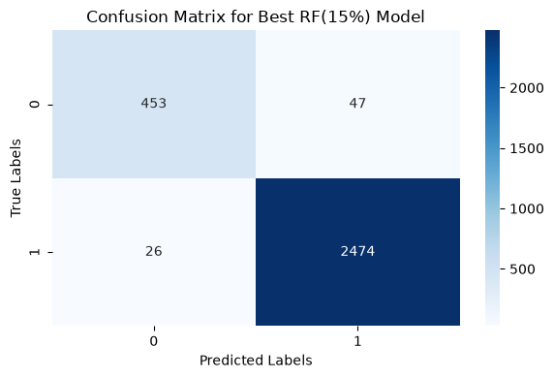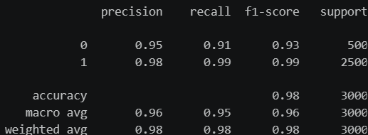
RF  Hyperparameter | Test size  15% | Best Parameters : {‘max_depth': 5, 'max_features': 14, 'min_samples_leaf': 2, 'n_estimators': 300}  Best Estimator : RandomFroestClassifier(max_depth=5, max_features=14, min_samples_leaf=2, n_estimators=300)
RF  Hyperparameter | Test size 5% | 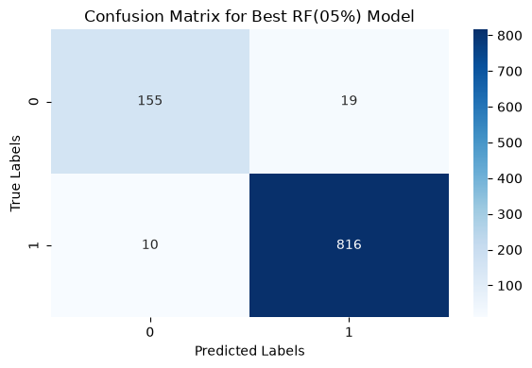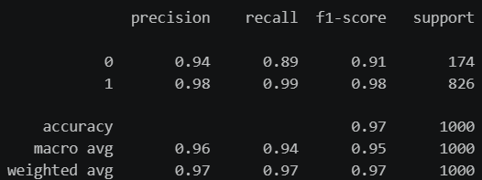
RF  Hyperparameter | Test size 5% | Best Parameters : {‘max_depth': 5, 'max_features': 14, 'min_samples_leaf': 1, 'n_estimators': 300}  Best Estimator : RandomFroestClassifier(max_depth=5, max_features=14, n_estimators=300))

Cross Validation
As what I did for SVC, I applied 10-fold cross-validation and I got a result of 97.6% of mean and 0.004 of std. It also means Random Forest model is stable and performs good to predict with this dataset. And when I compared this result with SVC one, The random forest performs slightly better.
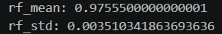

Comparing algorithms
Both models achieved very high accuracy of over 97% and a low standard deviation of about 0.003 in 10-fold cross-validation. This means that although SVC and Random Forest have completely different algorithmic prediction structures, both algorithms are successfully learned from the data.
The two models had different predictive structures. As compared, SVC is very sensitive to the standard scaler, whereas random forest is not affected by the scale. Additionally, while hyperparameter tuning with SVC takes much longer as the sample size increases, random forests offer an advantage over SVC if the number of inputs is not too large.
The question of which model to choose between the two arises. If the sample size is small, performance is not a concern regardless of the choice, but if the sample size is large, it is recommended to choose a random forest to reduce the time cost.

Conclusion
In this assignment, a comprehensive machine learning pipeline was successfully developed and evaluated to predict diabetes using a real-world healthcare dataset comprising 20,000 instances and 15 features. Through systematic data cleaning, custom mapping encoding, and exploratory data analysis, Glucose was identified as the primary predictor influencing the target variable Outcome. To address class imbalance and optimize performance, both Support Vector Classifier (SVC) and Random Forest models were implemented, tuned via GridSearchCV, and rigorously evaluated across multiple test-split ratios. To overcome the limitations of single train-test splits, a robust 10-fold cross-validation was conducted, revealing that both algorithms achieve exceptionally high predictive accuracy exceeding 97% with minimal standard deviation (~0.003). This confirms that the models possess superior generalization capabilities and are free from severe overfitting or underfitting. These models provide reliable and actionable insights for early diabetes risk detection, supporting better healthcare decision-making.

Appendix
AI competence | Reflective prompts (to students) | Student response
Delegation  Deciding whether & when to use AI | Identify the specific tasks in this assessment where you chose to use AI and explain your reasoning. Where did AI add value? Where did you decide not to use it, and why? | For this assignment, I used GEMINI as supporting tool for refining research questions, fix the error of the codes or grammar error. However, I did not choose to use to find the simple code that I learned from the classes.
Description  How you prompted the AI | Include the exact prompts you used in your appendix (recorded on the AI Tools declaration). Reflect on how you communicated your goals to the AI — did you need to iterate or refine your prompts to get useful output? | I used detailed prompting to communicate well and get an info about my problems. I did not use to get only one solution, I asked at least three solutions to compare them by myself, googling. By this method, I could increase my knowledge of data analytics
Discernment  Evaluating what the AI produced | In your reflection (~100 words), critically evaluate the AI output: what did you accept, modify, or reject — and why? Assess accuracy, relevance, and quality. You are responsible for verifying all AI-generated content before submitting. | I accepted AI’s suggestions by searching more information on google. For example, when AI suggested choose between smote, class_weight=’balanced’, decision threshold tuning for balancing target values, I chose class_weight=’balanced’ because I can check changes in the most intuitive way
Diligence  Responsibility for your AI use | Declare all AI tools used and cite them here. Briefly outline (~100 words) how you considered data protection, copyright, and ethical responsibilities when choosing what to input into any AI system. Unauthorised use is subject to CCT disciplinary procedures. | While using AI, I maintained ethical responsibilities by keeping it in my mind that no personal, confidential data was inputted into them.

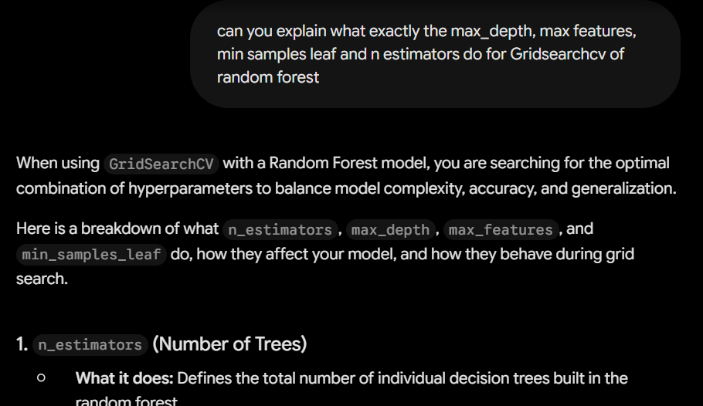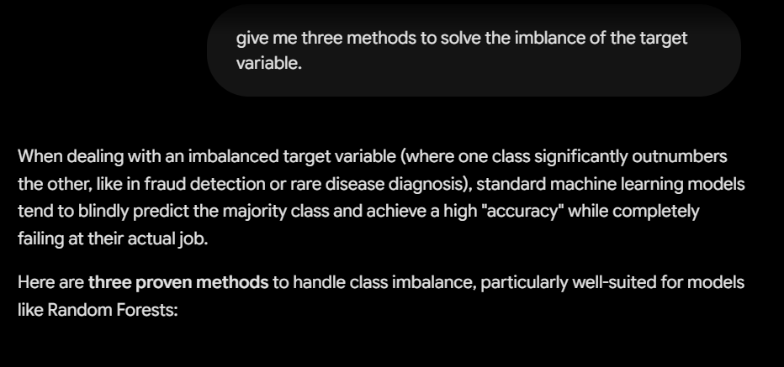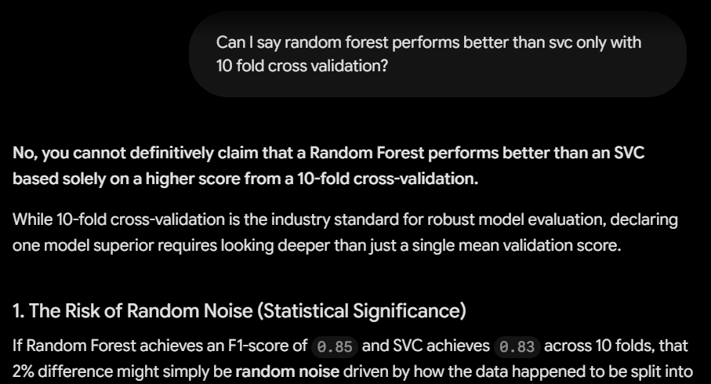

References
Tuhin, Izaz Ahmmed ; SIAM, A K M FAZLUL KOBIR; Haque, Md Afzalul (2025), “Diabetes Risk Prediction Dataset: Demographics, Lifestyle, and Clinical Indicators”, Mendeley Data, V2, Avaliable at: https://data.mendeley.com/datasets/xv25yjbzkm/2/files/a0843021-a3bd-4737-96c0-a19cacb84e54
WHO diabetes(2026) Available at :
https://www.who.int/news-room/fact-sheets/detail/diabetes (Accessed: 14 November 2026).
- Cited sentence : The number of people living with diabetes rose from 200 million in 1990 to 830 million in 2022. Prevalence has been rising more rapidly in low- and middle-income countries than in high-income countries.
seaborn.countplot Available at : https://seaborn.pydata.org/generated/seaborn.countplot.html
sklearn set_config Available at :
https://scikit-learn.org/stable/modules/generated/sklearn.set_config.html
scikit-learn Random Forest Available at :
https://casrai.org/guides/scikit-learn-random-forest
Sklearn Tuning the hyper-parameters of an estimator Available at :
https://scikit-learn.org/stable/modules/grid_search.html
Medium Random Forest with Grid Search Available at : https://medium.com/cloudvillains/random-forest-with-grid-search-b739fb0da311

Github link:
https://github.com/2026324-cmd/achine-Learning-HDip2026-

